Healthcare PGP

Python code file:

  

Tableau output:

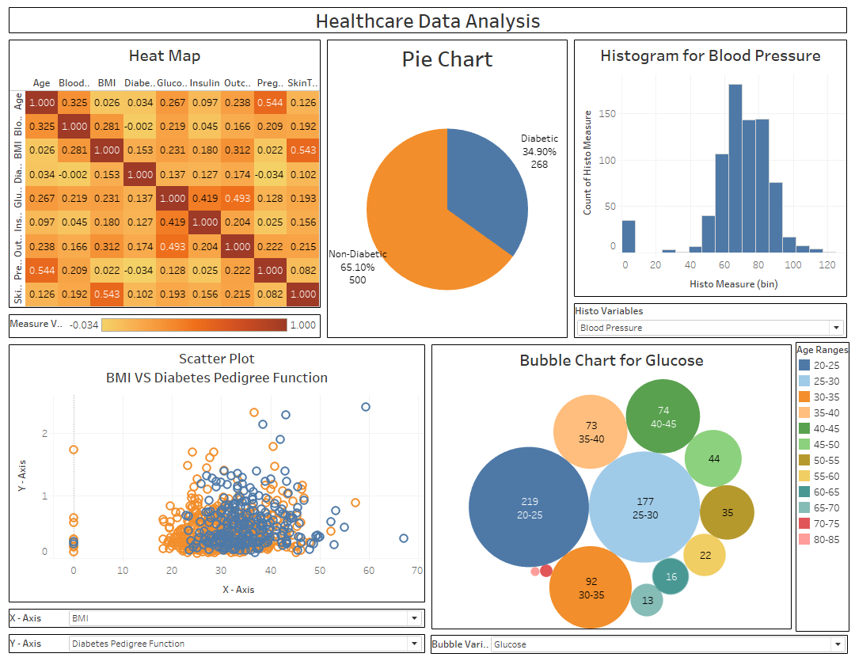

Tableau Workbook Link:

<https://public.tableau.com/app/profile/salim.malik3338/viz/Project2-HealthcarePGP/Dashboard?publish=yes>